

APTECH – UNIVERISTY ROAD CENTER

ARTS STATIONERY SHOP

Center Name: | Aptech University Road Center
 | 1st Floor Bell Arcade, Gulistan-e-Johar, Block-1, Main University Road, Opposite University of Karachi., Karachi, Pakistan
Instructor: | Sir Meesum Raza
Group members | Name |  | Student ID
 | M.Maaz Ahmed |  | Student1343020
 | Kashif Ali Khan  M.Shehryar |  | Student1327884  Student1318840
Project Duration | Start date | 09-Sep-2022
 | End date | 09-Oct-2022

This is to certify that

Mr.:
M.Maaz Ahmed
Kashif Ali Khan
______ M.Shehryar_____________________________________________________________________________

has successfully designed & developed
eProject: Arts Stationery Shop

Submitted by:
Kashif Ali Khan

Date of issue: 09-Sep-2022

Authorized Signature:

TABLE OF CONTENTS
ACKNOWLEDGE 4
SYNOPSIS 4
ANALYSIS 4
CUSTOMER'S REQUIREMENTS SPECIFICATIONS (CRS) 5
WEBSITE DESIGN 6
SCREENSHOTS ?
SOURCE CODE WITH COMMENTS ?

ACKNOWLEDGE
To have a successful project, it is the continuous effort of many people.
Earliest, we would like to express our appreciation to Aptech University Road Center and E-Project team for giving us a great environment for studying as well as this pleasant project. This is a huge opportunity for us to explore more knowledge, build up problem solving skills and teamwork spirit.
Inside this great organization, thank for Sir Meesum Raza – our teacher, with many years’ experience of teaching, along with enthusiasm as well as rigorous in guiding the project, he is the person who helped us complete the subject to catch the schedule can achieve our goal.
Moreover, we are grateful for having the support from our family, they did create the best conditions for us to focus on the project, and put faith in the dreams we are pursuing.
The finally yet importantly, this is the efforts and curiosity of the members in our group. We have focused on starting the project very early, promoting teamwork by sharing experiences and knowledge with each other throughout the project.

SYNOPSIS
Our client is a retail dealer of various products like gift articles, dolls, files, etc…. The customers usually visit the shop in order to purchase the products. He has a huge variety of products at his shop. Also as there is an increase in the demand of these products and as well as there is a huge variety of combinations and products available, and as the number of retail dealers are increasing day by day, it has become difficult to withheld in the market and as well to retain the customers.

Also as they don’t keep track of the products, it is hard to find how many products are available in the shop.

In order to cope up in this competitive world, and to retain the customers, to automate the process, this application is built meeting the current technology trend where the customers can place their order through online by sitting at their office/home, and providing the products as per the orders received by the dealer at the door steps of the customer.

ANALYSIS
Client says that he wants that the application should hold the details of the products in detail like price, description of the product and each product is allocated with a unique 7 digit product id which includes 2 digit product code and 5 digit product number. Also he says that for fetching the details of the products, the customer need not be the registered one, but for placing an order one has to be the registered user of the site.

After placing an order, the dealer would dispatch the order as per the type of delivery that the customer has chosen. He says that the application should generate a unique 16 digit order number (includes the type of the delivery (1 digit) that the user has opted for, Product id (7 digit), and the order number (8 digit)) as soon as the order is placed by the customer.

For the order which is placed through the credit card payment or through cheque, the payment should be cleared first and then only the product will be dispatched to the customer’s premises. Also he has provided an option like if the customer is not satisfied by the product then the customer can either replace it (new product will not be sent) or he can return it back with in a week days time, so that he can get back his money which he has paid for that product. Also the warranty card will also be provided for the products which have some warranty.

The dealer alone should be able to update the details of the employees, products and their details, and he can check the orders that are received based on the date, order type (delivery) and he alone has the right to create an employee profile like username or login id and the password. The employee should only be able to change his password, and he can check the details of the orders so that the products can be dispatched as per the customer’s request and that they can be delivered in time.

Also he says that there should be an option on the web site where the customer can send their feedbacks regarding the services that they attain from them.

CUSTOMER'S REQUIREMENTS SPECIFICATIONS (CRS)
Expected delivery date: 9 oct 2022
List of deliverables:
- Document Word.
- User Guide.
- Source code.

HARDWARE/ SOFTWARE REQUIREMENTS:
For webmaster

Hardware
- Intel Pentium 4 processor or higher
- 1 Gigabytes of RAM or higher

Software
- Windows 7 OS or higher
- Visual Studio
- Web browsers such as Chrome or Firefox are recommended.

For web users

Hardware
- Intel Pentium 4 processor or higher
- 512 Megabytes of RAM or higher

Software
- Windows XP OS or higher
- Web browsers such as Chrome or Firefox are recommended.

WEBSITE DESIGN
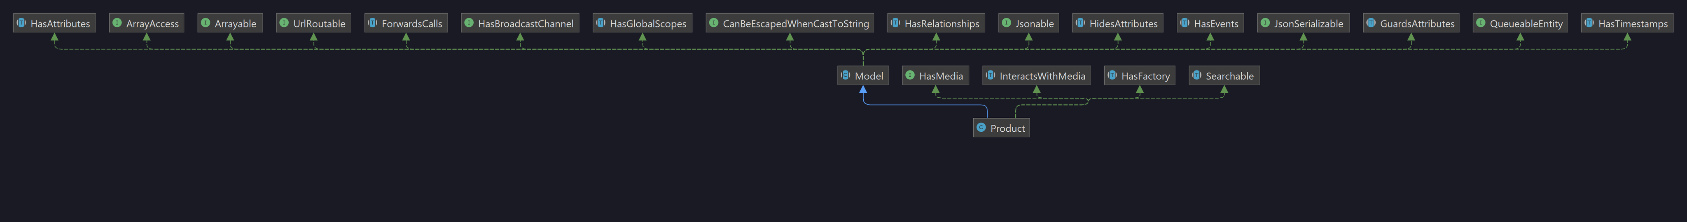

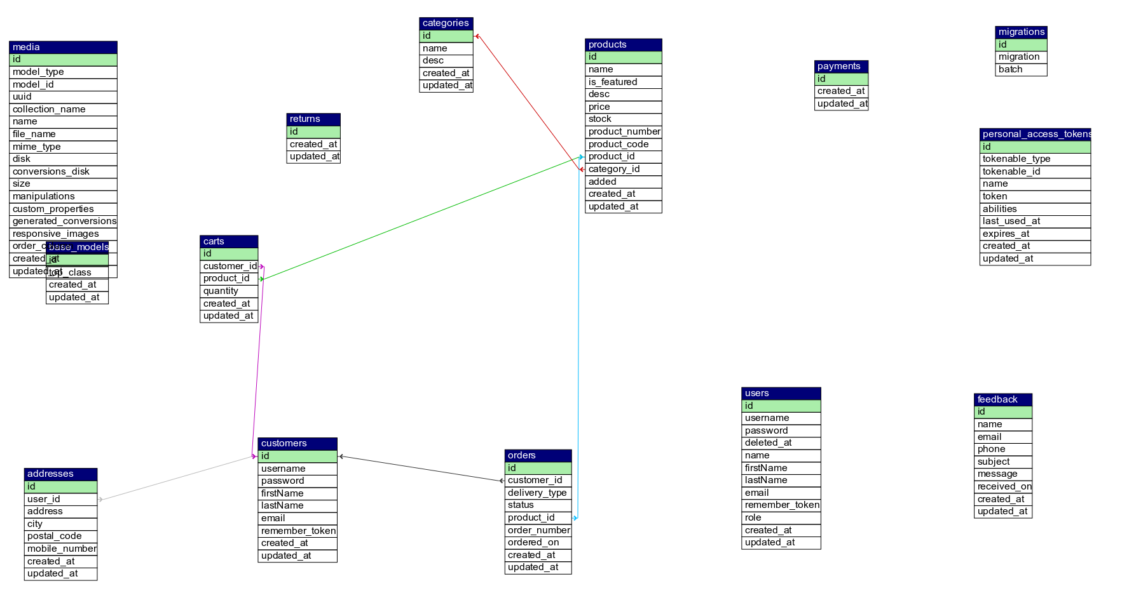

Detailed Website design is given as a separate file in the docs folder as website-design.pdf

SCREENSHOTS
1. Hompage
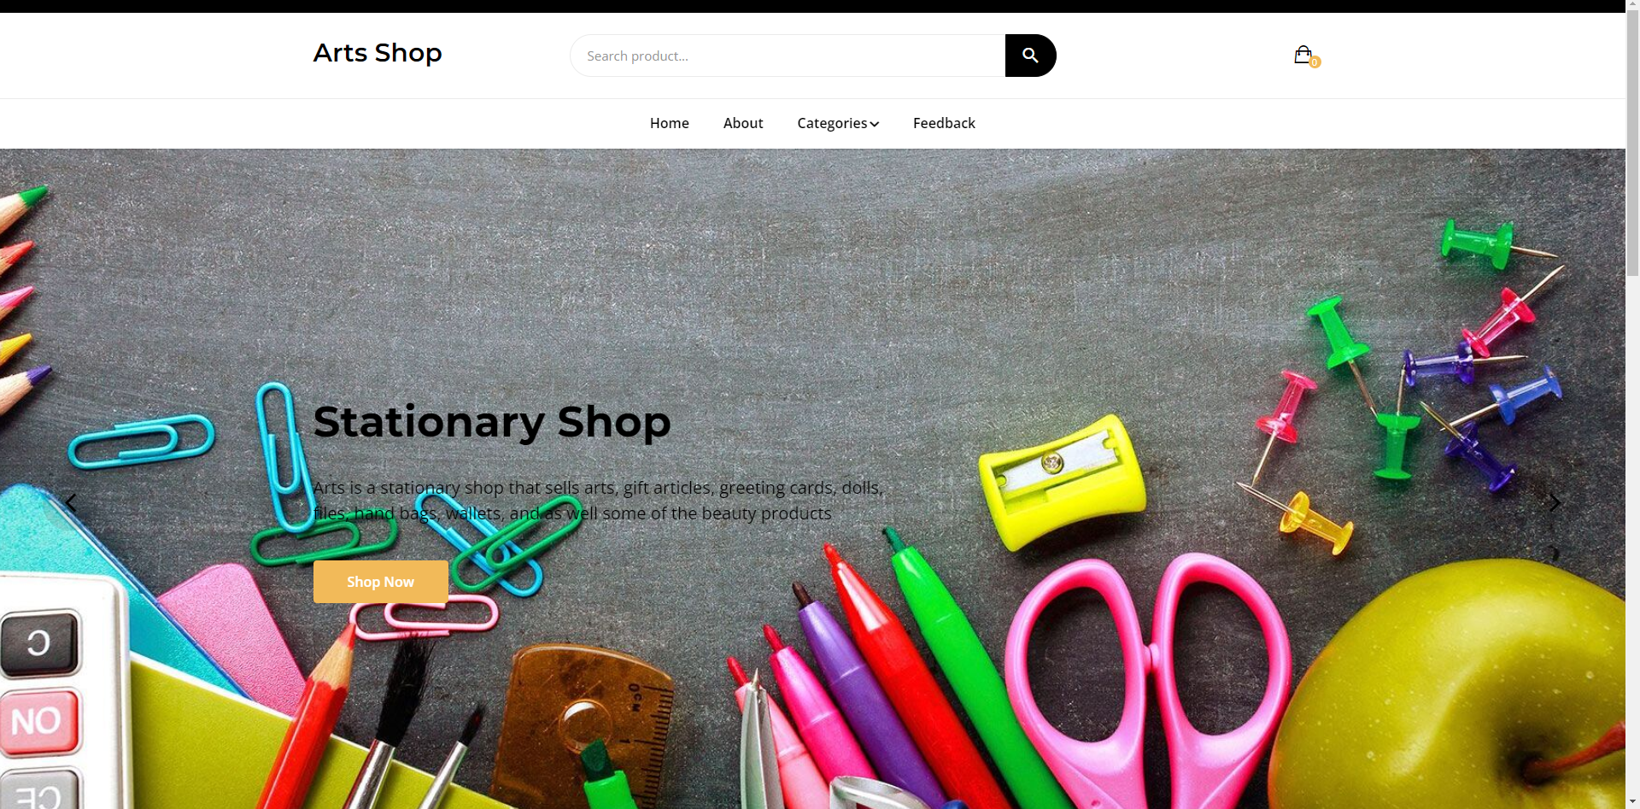
2.Dashboard
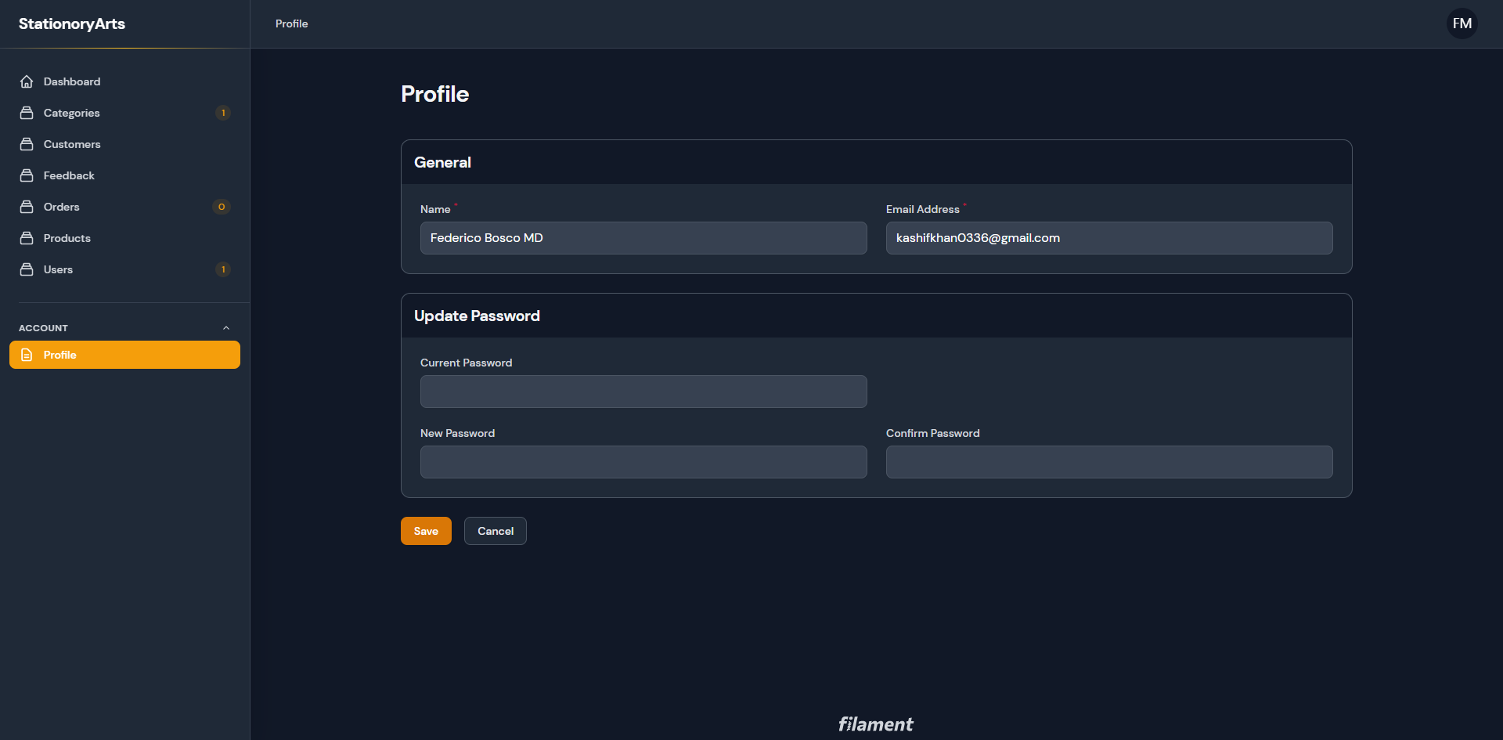
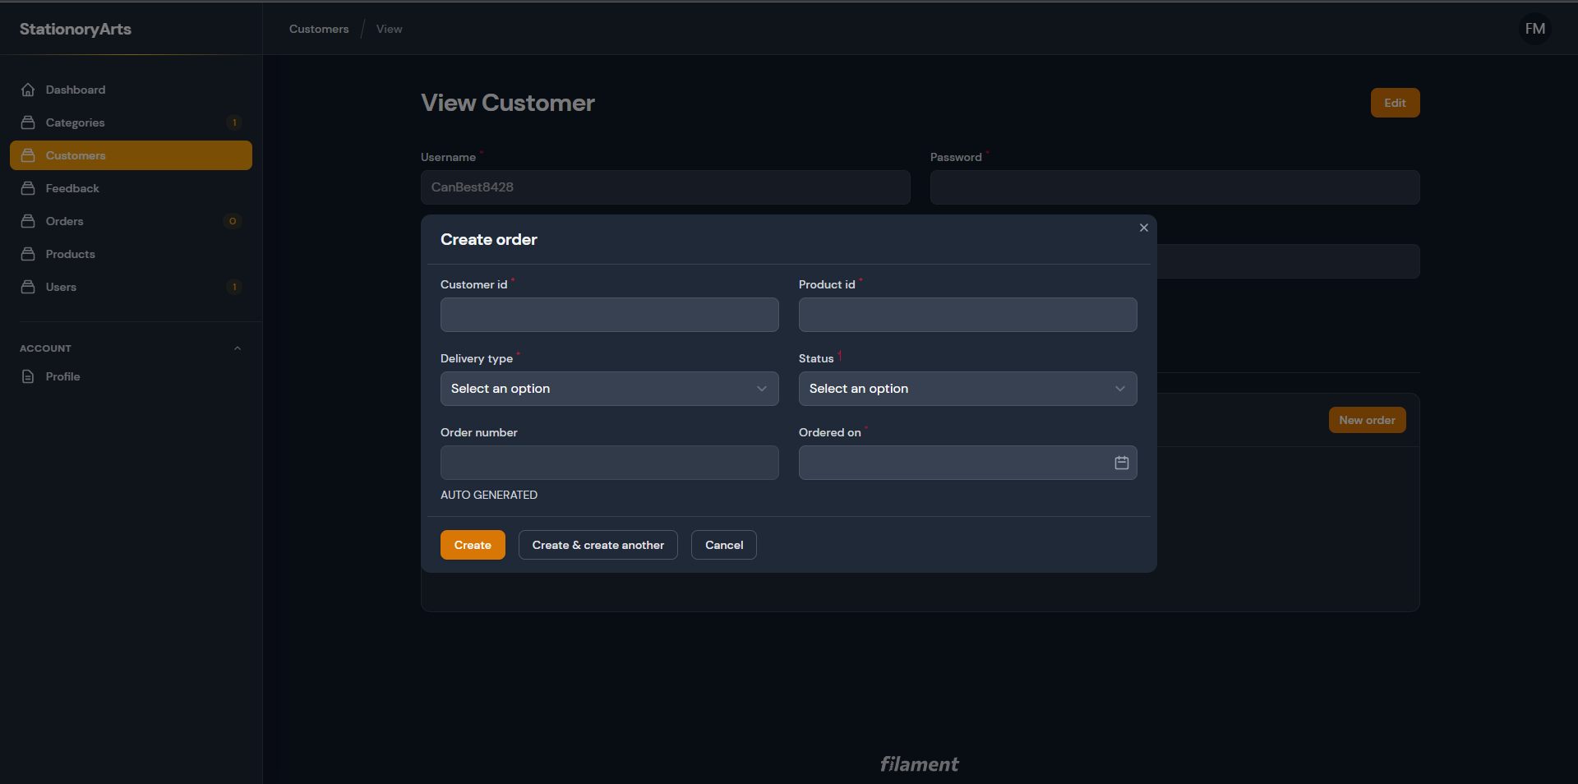
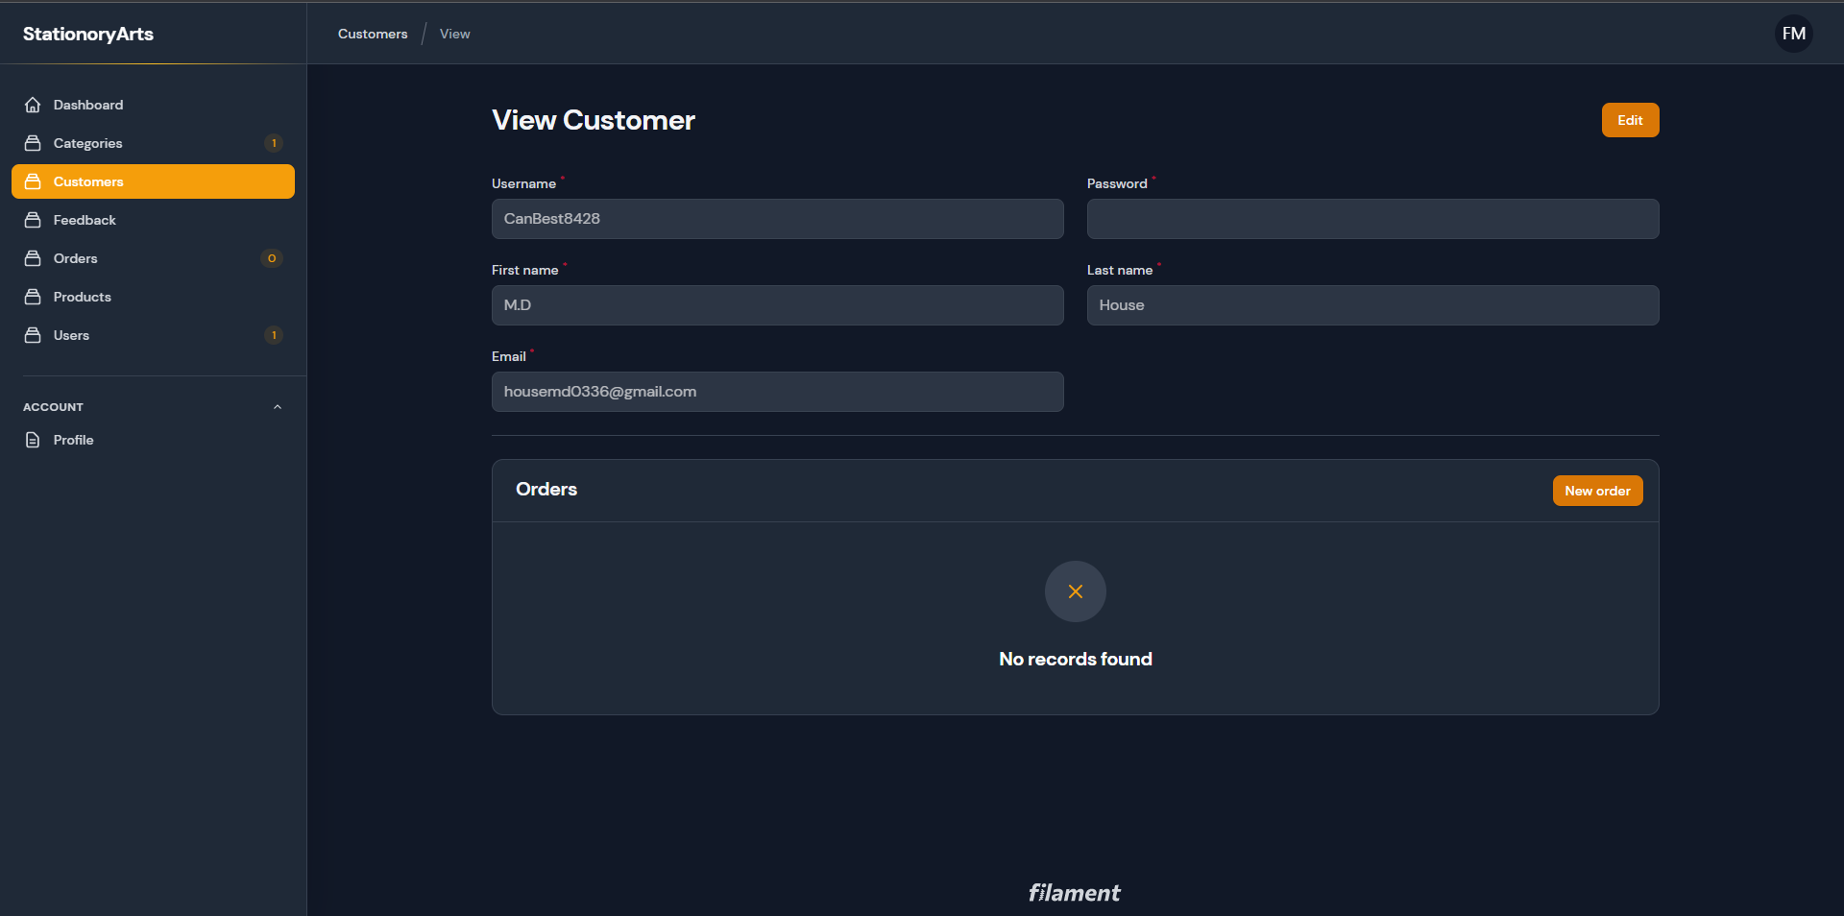

SOURCE CODE WITH COMMENTS
